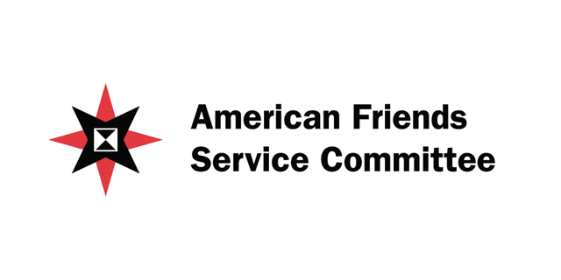
The five things Quaker Meetings/Churches can do to support a shift in budget priorities through the If I Had a Trillion Dollars youth film festival:
- Host a screening of the 3rd annual "If I Had A Trillion Dollars" youth film festival. Contact Erin Polley at 317-626-0868 or epolley@afsc.org for a copy of the DVD and advocacy materials.
- Purchase a vinyl banner of the US discretionary budget to hang on or in your Meetinghouse. The banner is 2.5 x 20 feet and is $200, shipping included. Contact Mary Zerkel at 312-427-2533 or mzerkel@afsc.org.
- Make a video! Visit www.ihtd.org for a full curriculum that can be used with the youth in your Meeting and will get them thinking about their budget priorities. Submit a video to the 4th annual film festival by January 2014. More info at www.ihtd.org.
- Spread the word about IHTD by liking us on facebook at www.facebook.com/IHTDFilms and following us on twitter @IHTDFilms.
- Take action and participate in the ongoing discussion on our nation's budget priorities. Visit www.afsc.org/wage-peace for access to toolkits, talking points and ways to take action in your community.

