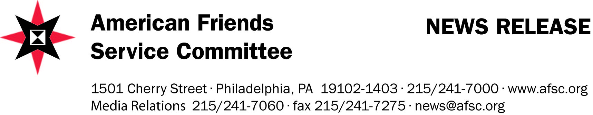
Contact: Jacob Enoh Eben
Phone: (257) 79 239 691 (257) 78 338 691
“Lessons Learned” From Truth and Reconciliation Commissions Planned
Delegates from 9 nations to Discuss Challenges, Share Successes of Commissions
BUJUMBARA, Burundi (August 22, 2011) - Over 50 participants from nine countries will gather in Bujumbura this week for the “Transitional Justice Mechanisms: Lessons Learned from Truth and Reconciliation Commissions” conference. The conference will run from August 24-26, 2011, at the Hotel Safari Gate, providing a framework for participants to exchange and share experiences on the lessons learned from such commissions. The conference is being organized by the American Friends Service Committee (AFSC) within its Dialogue and Exchange Program (DEP).
Participants represent countries that have already set up truth commissions, those who are in the process and those considering doing so. Topics to be discussed include truth commissions as instruments to redress past abuses and tools to promote human rights principles; international standards in developing laws governing such commissions, and their creation, organization, administration, challenges and successes in the different countries.
Participants include government and non-government representatives from Sierra Leone, Liberia, South Africa, Kenya, Uganda, Democratic Republic of Congo and Burundi and Latin America Some are current and former commissioners themselves. They will share the challenges and successes of setting up truth commissions in their respective countries.
“Finding prudent mechanisms to deal with past crimes and restoring justice are not only daunting challenges but also foundational to build durable peace for many communities and nations across the world and the lessons from the conference will profoundly be important” says Dereje Wordofa, the Regional Director for Africa. “This sharing and exchange of experiences will also help Burundi to draw useful lessons especially at this time when the country is preparing to establish its own Truth and Reconciliation Commission.”
Founded in 1917 in Philadelphia, PA in the US, the American Friends Service Committee (AFSC) is a Quaker organisation that works internationally in the areas of peace, social justice and humanitarian service. In 2005, AFSC was officially accredited by the Government of Burundi Since 2008, it has been hosting similar conferences and events, including those on mediating elections-related conflicts and a study tour to Sierra Leone on peaceful elections.

