CALL TO JOIN U.S. AND GLOBAL DAYS OF ACTION ON MILITARY SPENDING

APRIL 5 – 18 (U.S. Focus April 16-18)
Beginning on 2011, people and organizations across the U.S. and around the world have joined with the International Peace Bureau to organize the Global Day of Action on Military Spending (GDAMS) events each April to coincide with the release of the annual world military expenditure figures by the Stockholm International Peace Research Institute (SIPRI). It is also timed to coincide with Tax Day, when U.S. citizens pay their taxes and debate their use.
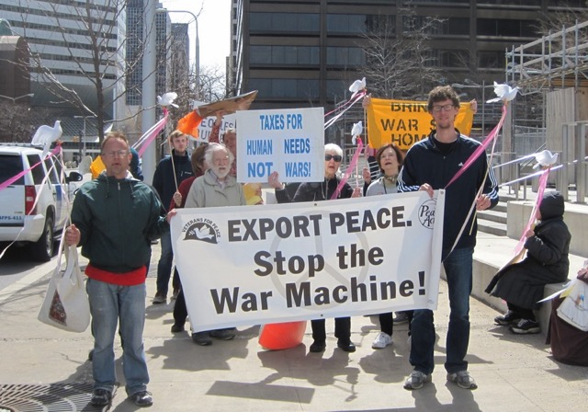
GDAMS engages people across the world in collaborative actions to focus public, political, and media attention on the costs of military spending and the need for new priorities.

We are writing to encourage you to join activists across the U.S. and internationally in this year’s GDAMS activities. The Pentagon has inflated its budget request to nearly $600 billion, including $58.8 billion for its “overseas contingency operations” – wars - and to quadruple spending for war preparations in Eastern Europe. In the coming years, our government is planning to spend $1,000,000,000,000 to modernize its nuclear arsenal and its delivery systems, a small fraction of which could bring on nuclear winter. The new F-35 fighter/bombers are set to cost $1,500,000,000,000 over their “lifetime.” In addition to encouraging and fueling the catastrophic destruction of wars, this spending claims and truncates lives without a shot being fired, a bomb dropped or a missile launched.
Global military spending has surged to an all-time high of more than $1.75 trillion. Given the numerous needs and crises in the U.S. and internationally – water that’s not poisoned, reversing and coping with climate change, the basics of food, housing, education and medical care – it is clear that our, and many other nations’, national budget priorities are seriously wrong and dangerous.
A major reconceptualization and reallocation is needed. It starts with us and the Global Days of Action on Military Spending. Thousands of organizations and millions of individuals share this commitment. What is needed is a serious mobilizing to impact policy makers.
Each group and community engaged in GDAMS is encouraged to craft its own approach. This can be linked to national, local, or international peace, justice and environmental issues. They can, for example be linked to welfare cuts, hospital and school closures, reductions in pensions or development cooperation; economic inequality, and investing in climate change.
We encourage groups and individuals to use Global Days as an opportunity to connect across sectors — peace, environment, development, labor, youth, faith-based, and anti-poverty organizations who understand the interdependence of our issues. Our only request is that events include opposition to military spending.
The number of GDAMS actions has increased each year and have spanned an array of imaginative possibilities from flash mobs and street theatre, to penny polls, banner displays, seminars, signature collections and concerts; social media campaigns: Selfies or groupies on Facebook, Instagram or Pinterest; video productions on YouTube; and any combination that works. The idea is to generate captivating actions, images and powerful messages to engage people in our communities, impact the decision-makers, and attract media coverage.
GDAMS is key part of the permanent year-round [www.gcoms.org] Global Campaign on Military Spending (GCOMS), also coordinated by the International Peace Bureau. Join activists from all over the world at the Berlin Congress: [www.ipb2016.berlin] Disarm! For a climate of peace: Sept 30 - Oct 3, 2016 - where the military spending campaign will have a central place.
Ideas and tools for organizers are available in the Organizers’ Materials and Previous GDAMS sections.
Please also post your GDAMS/U.S. Tax Day activities on the world map and send us photos or links to your events.
Website: http://demilitarize.org/
Email: mbass@afsc.org

