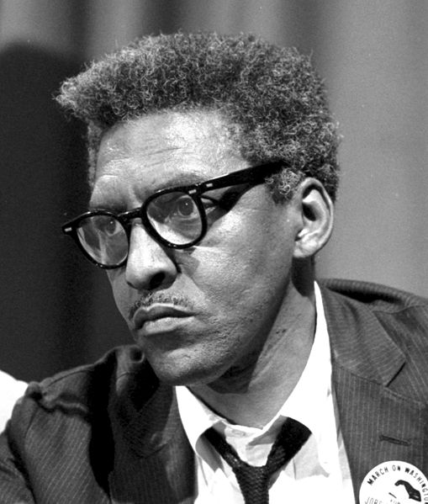
THE LIFE OF BAYARD RUSTIN AND HIS LEGACY FOR TODAY

Friday January 25rd from 7:00pm to 9:00pm

Friends Meeting House, 4836 Ellsworth Ave
Oakland

There will be a showing of the movie, “Brother Outsider” followed by a panel discussion.

This event is in conjunction with the 15th Annual Black and White Reunion Summit Against Racism, which will be held January 26th at 9:00am at the East Liberty Presbyterian Church.
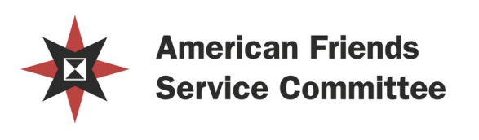
For more information please contact: Scilla Wahrhaftig 412 315 7423 swahrhftig@afsc.org

